*Florida International University*

*School of Computing and Information Sciences*

CIS 4911 - Senior Capstone Project

Software Engineering Focus

Feature Document

User Story #956

Testing and Modifying - Register User / New User Email Verification / User Login processes

**Team Member:**

Vladan Lalovic

**Product Owner(s)**:

Masoud Sadjadi

**Mentor(s)**:

Mohsen Taheri

**Instructor**: Masoud Sadjadi

# 

# 

# 

# **User Story - Testing and modifying login, email verification, and create an account process**

* As a developer, I would like to test and modify the process of creating an account, verifying the account via email, and logging in, so that I know they work well.

## **Use Case**

**Use Case ID:** (VIP-956)

**Details:** Testing and Modifying the Register User / User Login / New User Email Verification processes

**Actor:** Developer

**Pre-conditions:**

1. Developer has navigated to the VIP website.
2. Developer is browsing the VIP website as a Guest User (not logged into any account, all “vip.fiu.edu” cookies **cleared** from the current browser session).
3. Developer is logged into his/her email account – in order to receive the account verification email.

**Description:**

1. Use case begins when the Developer navigates to the “Login Page” (http://vip.fiu.edu/#/login).
2. The “Login Page” will have a link labeled with the text “Create an account”.
3. Developer will click on the “Create an account” link, and will be redirected to the “Registration Page” (<http://vip.fiu.edu/#/registration>).
4. Developer will fill out all of the requested information on the “Registration Page” in its entirety. (i.e., First Name, Last Name, ect).
5. Developer will click the “Create Account” button at the bottom of the “Registration Page”.
6. If the registration was successful, the Developer will see the message “Account Registration successful, please check your email for the account verification email” at the bottom of the page.
7. Developer will open the account verification email, and click the link contained in the email.
8. Developer will be directed to a page on VIP that says “Email Verified”.
9. Developer will navigate to the “Login Page” (<http://vip.fiu.edu/#/login>).
10. Developer will enter the “email” and “password” of the account that was just verified in the designated fields, accurately, and click the “Log in” button.

**Post-conditions:**

1. Developer will be redirected to the “User Profile” page (<http://vip.fiu.edu/#/profile>), which indicates a successful login.
2. An account with the same “email” does not exist in the database already.

**Alternative Courses of Action:**

N/A

**Exceptions:**

N/A

**Related Uses Case:**

N/A

**Decision Support:**

**Frequency:** Low. Estimated average of one addition per application execution.

**Criticality:** High. Needed for the site to function correctly.

**Risk:** Low.

**Constraints:**

1. **Usability:** 
   1. No training time required.
   2. User guide should provide more in-depth information.
2. **Reliability:** 
   1. Mean time to Failure – 5% failures for every twenty four hours of operation is acceptable.
   2. Availability – Down time for Login Back-up 30 minutes in a 24 hour period.
3. **Performance:** 
   1. Registration, Email Verification, and Login should takes less than 5 seconds to process server-side.
4. **Supportability:**
   1. All modern web browsers should be supported.

**Modification History:**

**Owner:** Vladan Lalovic

**Initiation date:** 5/28/2016

**Date last modified:** 5/31/2016

**Use Case Diagram**

N/A

**Sequence Diagram**

N/A

**Class Diagram**

N/A

**Unit & Integration Tests:**

**Test Case 1 (Sunny Day)**

**ID: VIP-SD-717-01**

**Purpose**

* Ensure the “Registration Page” creates a new user account in the database.

**Precondition**

* Developer fills out the entire Registration form.

**Input**

* Developer Clicks on the “Create Account” button at the bottom of the page.

**Expected Result**

* User is added to database as an “inactive” user.

**Actual Result**

* Same as expected.

**Test Case 2 (Sunny Day)**

**ID: VIP-SD-717-02**

**Purpose**

* Ensure Email Verification works, and activates the account successfully.

**Precondition**

* Developer has registered a new account via the “Registration Page”, and encountered no errors while doing so.

**Input**

* Developer clicks on the “Activation URL” that is sent to them via email.

**Expected Result**

* The Developer is redirected to the “Account Verification” page and is displayed a “Email Successfully Verified” message.

**Actual Result**

* Same as expected.

**Test Case 3 (Sunny Day)**

**ID: VIP-SD-717-03**

**Purpose**

* Ensure Login works when a **valid and verified** email/password combination is submitted.

**Precondition**

* Developer is using the login credentials for an **existing account** that has been previously **verified** via email.

**Input**

* Developer navigates to the “Login Page”
* Developer fills out the “email” and “password” fields on the “Login Page” with valid credentials.
* Developer clicks the “Log in” button.

**Expected Result**

* Developer is logged into the account, a session cookie named **“connect.sid”** is stored in the browser, and the Developer is redirected to the “Profile Page” for the account.

**Actual Result**

* Same as expected.

## **User Guide**

**Step 1:** Developer Fills out registration form completely.

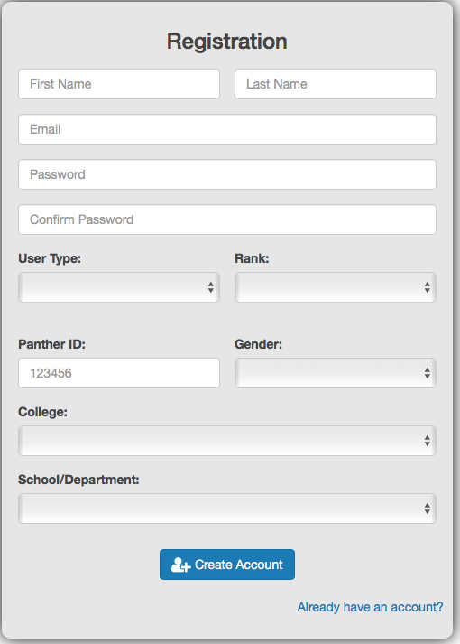

**Step 2:** Developer double checks that all information is correct, and presses “Create Account” button on the bottom of the page.

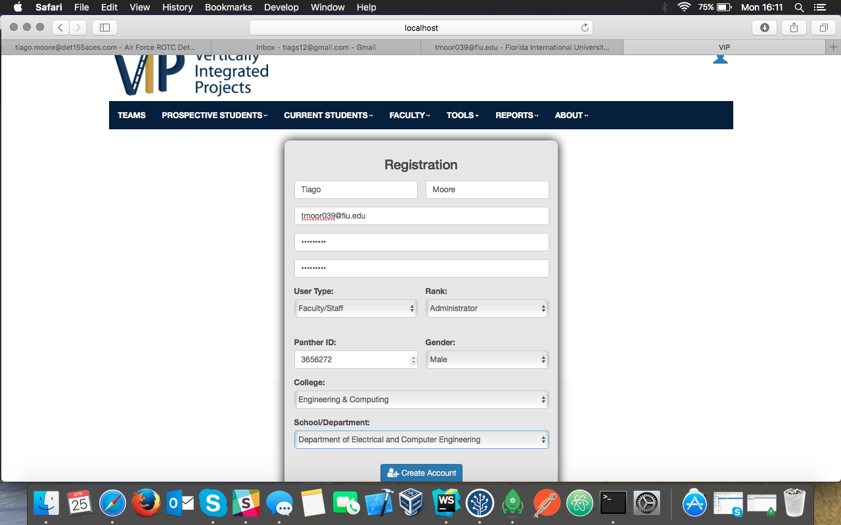

**Step 3:** Developer Verifies Email

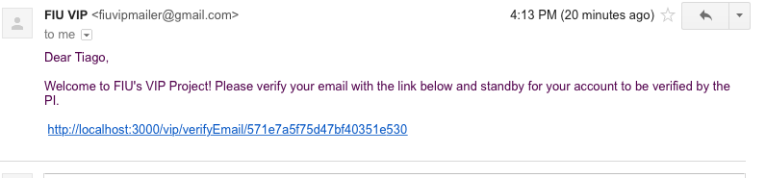

**Step 4:** Developer Clicks on link:

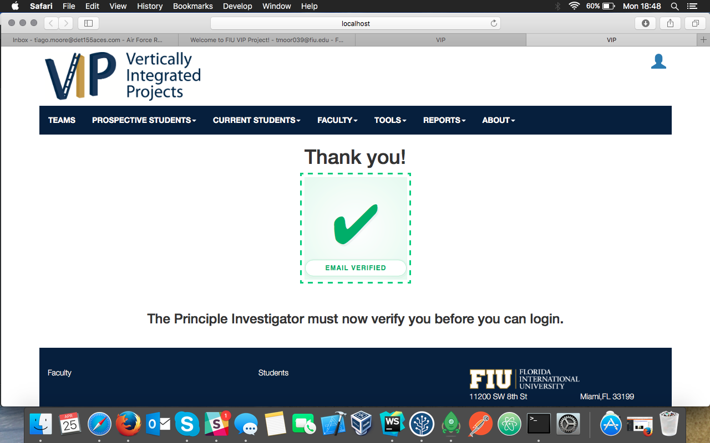

**Step 5:** Developer Gets Email / Clicks Link /

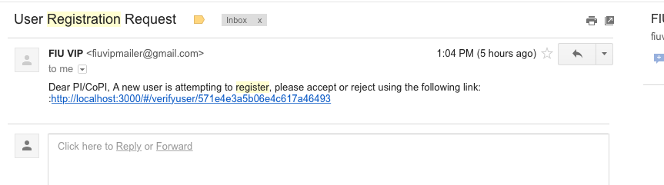

**Step 6:** Developer can Accept or Reject the user. If accepted, the user is able to login.

